**ABOUT THE 50 STARTUPS DATASET**

**ASSIGNMENT -1**

**K.RAJASRI**

**113219041091**

* Based on R&D spend by profit and states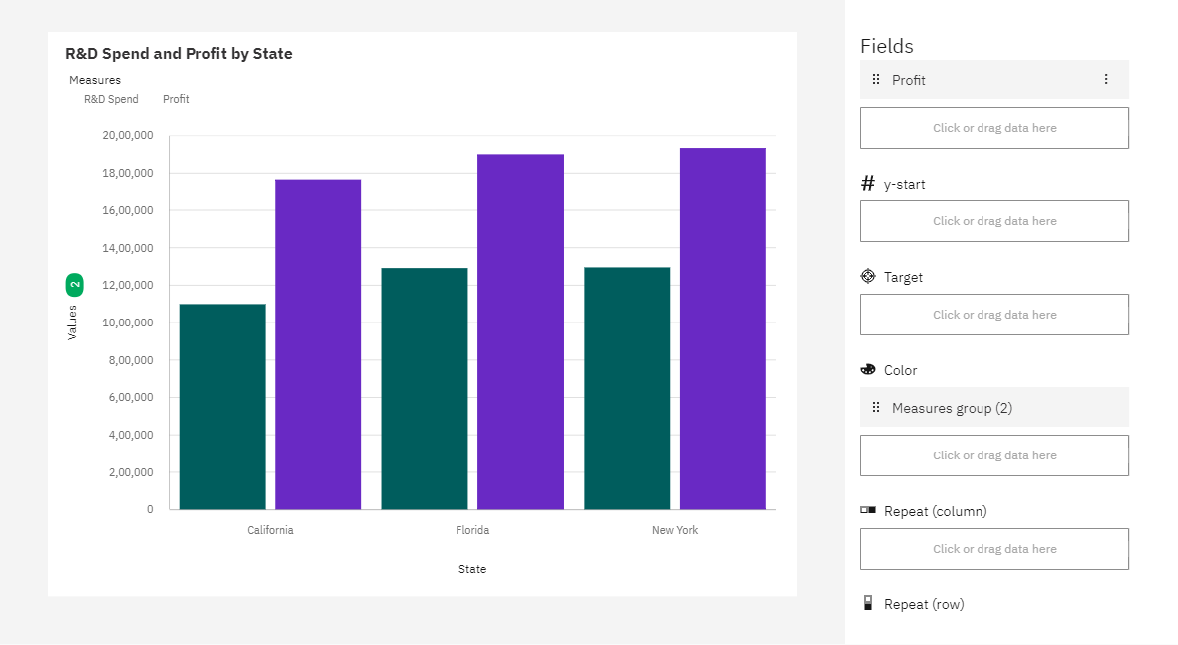
* Based on Marketing and Administration by states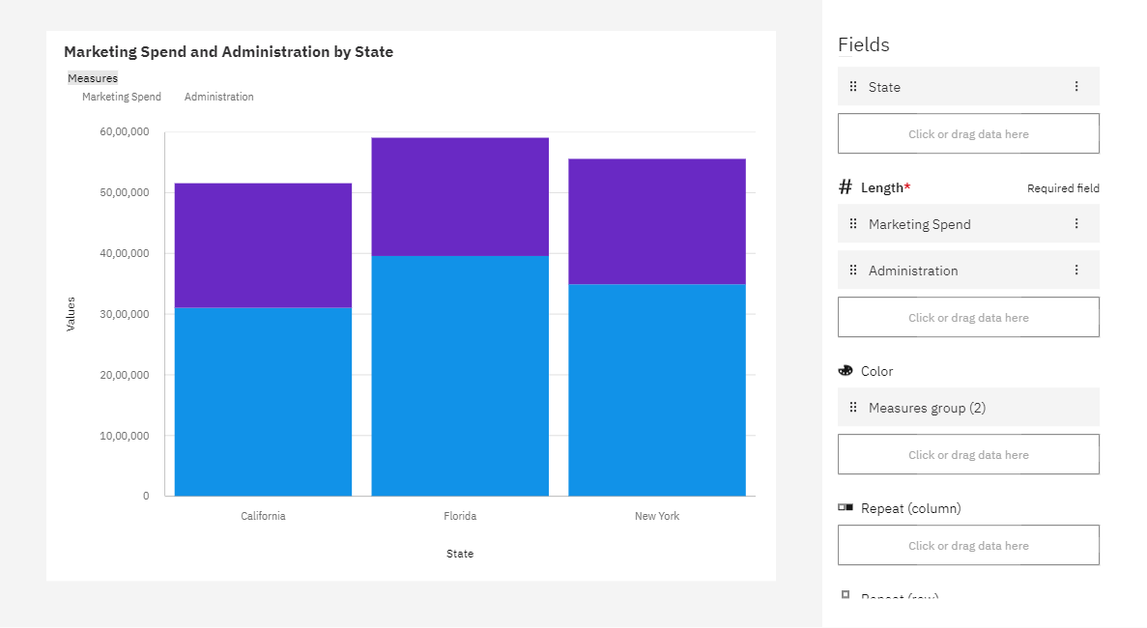
* Based on Administration and profit by states

